PC HYPER TERMINAL

1. Start a HyperTerminal session from the start menu:

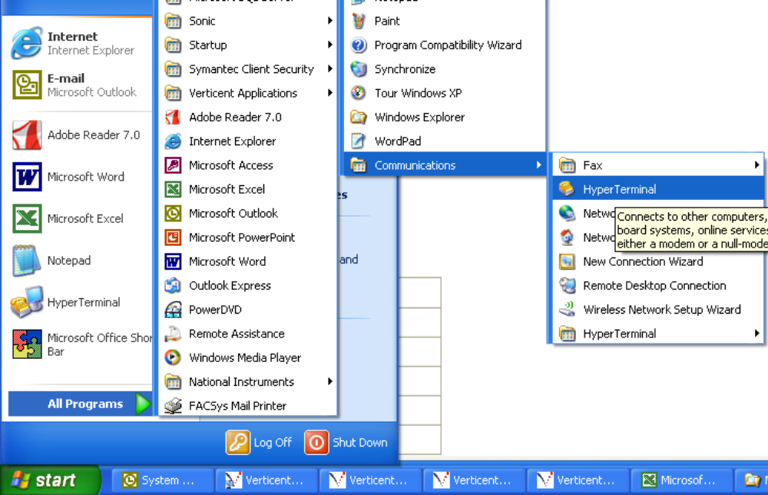

2. Enter a name for the terminal session (e.g., LS 331, LS 332, LS340) and click OK.

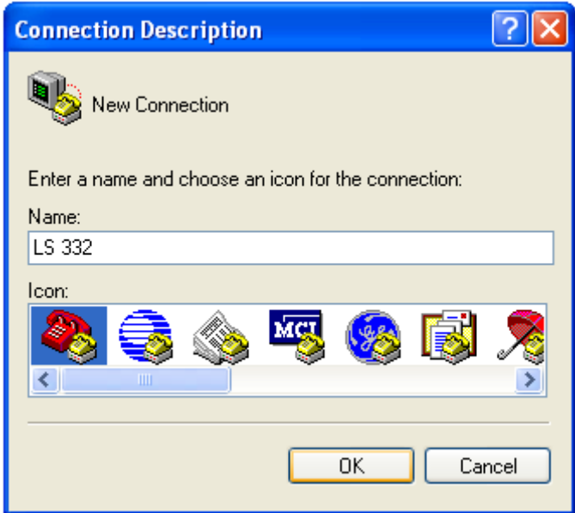

3. Select the COM Port you will be using and click OK:

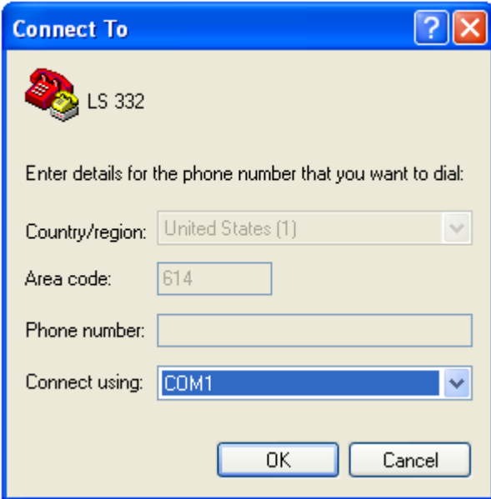

4. Enter the configuration information for baud rate, data bits, parity, and flow Control as provided in the instrument manual, then click OK.

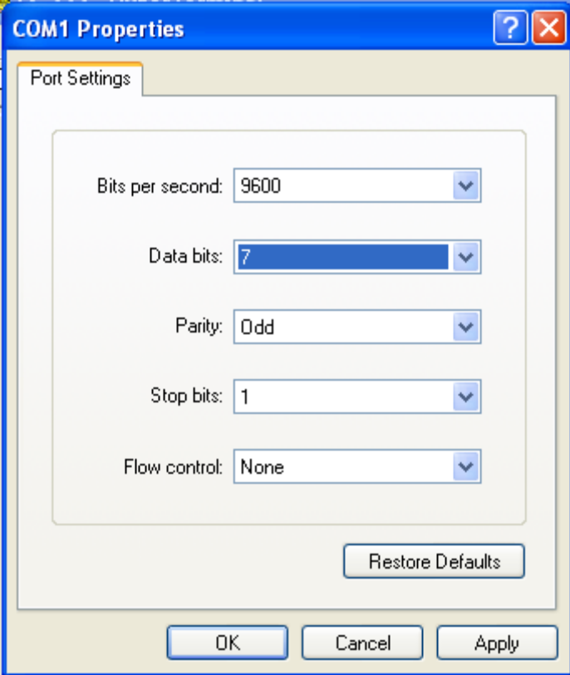

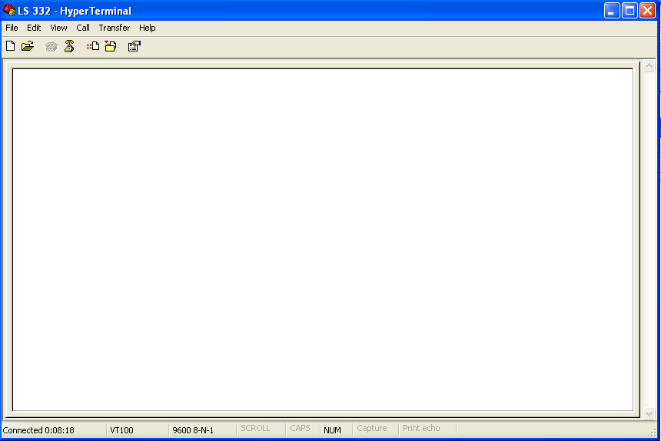

9-PIN Serial Connector:

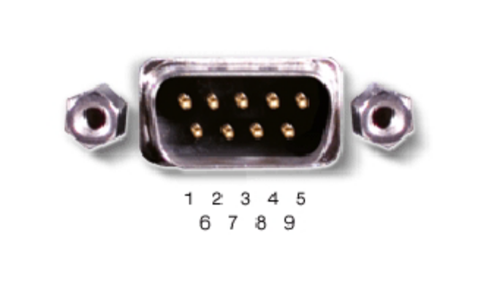

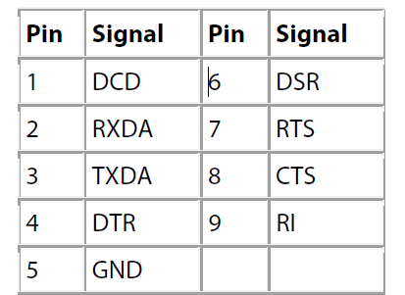

To construct a cable for connecting a PC equipped with a male DB9 connector to any Lake Shore instrument with a male DB9 RS232 interface connector, obtain two female DB9 connectors and place a strap between pins 1, 4, 6, and 8 on each connector. Using 50 ft or less of tightly twisted cable, connect pin 2 to pin 3, pin 3 to pin 2 and pin 5 to pin 5 of the two connectors.

